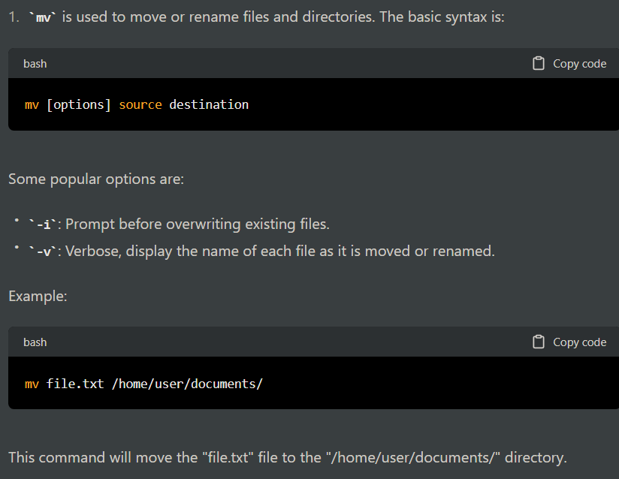

1. **useradd** Command: The **useradd** command is used to create a new user account on a Linux system. Here's an example:

Example: **sudo useradd -m john**

This command creates a new user account named **john** with a home directory (**-m** option) in the default location (**/home/john**).

Important flags for **useradd** command:

* **-m**: creates the home directory for the user
* **-s**: specifies the default shell for the user
* **-g**: specifies the primary group for the user
* **-G**: specifies additional groups for the user
* **-p**: sets the password for the user (it should be encrypted)

1. **usermod** Command: The **usermod** command is used to modify an existing user account on a Linux system. Here's an example:

Example: **sudo usermod -aG sudo john**

This command adds the user **john** to the **sudo** group (**-aG** option) to give them sudo privileges.

Important flags for **usermod** command:

* **-aG**: appends the user to the specified group
* **-s**: changes the default shell for the user
* **-l**: changes the username for the user
* **-L**: locks the user account
* **-U**: unlocks the user account
* **-p**: sets the password for the user (it should be encrypted)

1. **userdel** Command: The **userdel** command is used to delete an existing user account on a Linux system. Here's an example:

Example: **sudo userdel -r john**

This command deletes the user **john** and their home directory (**-r** option) from the system.

Important flags for **userdel** command:

* **-r**: removes the user's home directory and mail spool
* **-f**: forces the deletion of the user account, even if it is still logged in or has running processes

1. **groupadd** Command: The **groupadd** command is used to create a new group on a Linux system. Here's an example:

Example: **sudo groupadd developers**

This command creates a new group named **developers**.

Important flags for **groupadd** command:

* **-g**: specifies the group ID for the new group
* **-r**: creates a system group (with an ID less than 1000)
* **-f**: forces the creation of the group, even if it already exists

1. **cpio** Command: The **cpio** command is used to create or extract archives in various formats. It is a command-line tool used to copy files to and from archives, or to create archives.

Example: To create a backup of a directory called "mydir" and store it in a file called "backup.cpio", use the following command:

**find mydir -depth | cpio -ov > backup.cpio**

This command uses the **find** command to list all files in the directory "mydir", and pipes that list to **cpio**, which then creates an archive of the files and writes it to the file "backup.cpio".

Example: To extract the files from the "backup.cpio" archive, use the following command:

**cpio -id < backup.cpio**

This command uses the **cpio** command with the **-i** (extract) and **-d** (create directories as needed) options to extract the files from the "backup.cpio" archive.

Important flags for **cpio** command:

* **-i**: extracts files from an archive
* **-o**: creates an archive
* **-v**: verbose mode (displays progress and details)
* **-d**: create directories as needed
* **-F**: specify the archive file name

1. **tar** Command: The **tar** command is used to create or extract tar archives, which are commonly used for backups and distribution of files.

Example: To create a backup of a directory called "mydir" and store it in a file called "backup.tar", use the following command:

**tar -cvf backup.tar mydir**

This command creates a tar archive of the "mydir" directory and writes it to the file "backup.tar".

Example: To extract the files from the "backup.tar" archive, use the following command:

**tar -xvf backup.tar**

This command extracts the files from the "backup.tar" archive.

Important flags for **tar** command:

* **-c**: creates an archive
* **-x**: extracts files from an archive
* **-v**: verbose mode (displays progress and details)
* **-f**: specify the archive file name
* **-z**: compresses or decompresses using gzip
* **-j**: compresses or decompresses using bzip2
* **-t**: list the contents of an archive
* **-C**: specify the directory to extract to.

1. **fdisk** Command: The **fdisk** command is used to create, modify, and delete partition tables on hard disk drives. Here's an example:

Example: **sudo fdisk /dev/sda**

This command opens the partition editor for the **/dev/sda** device.

Important flags for **fdisk** command:

* **n**: create a new partition
* **d**: delete a partition
* **p**: print the partition table
* **q**: quit without saving changes
* **w**: write the changes to disk

1. **mkfs** Command: The **mkfs** command is used to create a file system on a disk partition. Here's an example:

Example: **sudo mkfs.ext4 /dev/sda1**

This command creates an **ext4** file system on the **/dev/sda1** partition.

Important flags for **mkfs** command:

* **-t**: specify the file system type to create
* **-c**: check for bad blocks
* **-L**: set the volume label
* **-m**: set the reserved block percentage
* **-b**: set the block size

1. **fsck** Command: The **fsck** command is used to check and repair file systems on a disk partition. Here's an example:

Example: **sudo fsck.ext4 /dev/sda1**

This command checks and repairs an **ext4** file system on the **/dev/sda1** partition.

Important flags for **fsck** command:

* **-a**: automatically repair any errors
* **-c**: check for bad blocks
* **-f**: force a check even if the file system is clean
* **-y**: answer "yes" to all prompts

1. **shutdown** Command: The **shutdown** command is used to shut down or reboot a Linux system. Here's an example:

Example: **sudo shutdown -h now**

This command shuts down the system immediately (**-h** option) and without delay (**now** argument).

Important flags for **shutdown** command:

* **-h**: halt the system (shut down)
* **-r**: reboot the system
* **-c**: cancel a scheduled shutdown or reboot
* **+m**: delay shutdown or reboot by "m" minutes
* **now**: shut down or reboot immediately.